|  |
| --- |
| **DEPARTMENT OF COMPUTER APPLICATIONS**  **T. JOHN COLLEGE**  (Affiliated to Bangalore University & Approved to AICTE)  Gottigere, Bengaluru – 560 083  **OPEN-AI IMAGE GENERATOR**  A project report submitted to the Bangalore University in the partial fulfilment  Of the requirements for the award of the degree of  **MASTER OF COMPUTER APPLICATION**  Submitted by  **Naveen Kumar S R**  **(P03ML21S0047)**    Under the guidance of  **Dr. FELCY JUDITH**  (Head of the Department, Computer Applications)  **May – 2023** |



**DEPARTMENT OF COMPUTER APPLICATIONS**

**T. JOHN COLLEGE**

(Affiliated to Bangalore University & Approved to AICTE)

Gottigere, Bengaluru – 560 083

**PROJECT WORK**

**OPEN-AI IMAGE GENERATOR**

**Bonafide Work Done by**

**Naveen Kumar S R**

**()**

The project submitted in partial fulfilment of the requirements for the award of

Master’s of Computer Application, of Bangalore University, Bengaluru.

**GUIDE**   **HEAD OF THE DEPARTMENT**

**Submitted for the Viva-Voce Examination held on**

**INTERNAL EXAMINER EXTERNAL EXAMINER**

**DECLARATION**

I, **Naveen Kumar S R (P03ML21S0047)** hereby declare that the project entitled **OPEN-AI IMAGE GENERATOR** is my project work carried out during the 3rd Semester MCA at T. John College, Bengaluru, under the guidance of **Dr. FELCY JUDITH** HOD, Department of Computer Applications, T. John College and has not submitted previously for the award of any other degree or diploma by me to any institution or university according to the best of my knowledge.

**SIGNATURE OF THE CANDIDATES**

**Place:** Bengaluru

**Date:**

**ACKNOWLEDGEMENT**

The project titled **OPEN-AI IMAGE GENERATOR**

has been successfully completed my project with the help of my faculty. I thank her for providing great tips that I have incorporated in this project.

I would express my sincere thanks to **Sr. ROSE MARY BALAPPA**, Principal, T. John College for her valuable advice, co-operation and support and for providing all the faculties for the construction of the project.

I am thankful to **Dr. FELCY JUDITH**, Head, Department of Computer Applications department for her valuable advice and co-operation.

Last but not the least we also like to thank our friends and family for their valuable support and encouragement.

**CONTENTS**

1. **CHAPTER 1 PAGE**
   1. **INTRODUCTION…………………………………………...…6**
   2. **PURPOSE OF THE PROJECT……………………………….7-8**
2. **CHAPTER 2**
   1. **LITERATURE SURVEY……………………………………...9-10**
3. **CHAPTER 3**
   1. **DATASET……………………………………………………..11**
   2. **DATA PROCESSING………………………………………....12**
4. **CHAPTER 4**
   1. **SYSTEM ANALYSIS AND DESIGN……………….………..13-14**
5. **CHAPTER 5**
   1. **SOFTWARE REQUIREMENT……………………………....15**
   2. **HARDWARE REQUIREMENT……………………………...15**
6. **CHAPTER 6**
   1. **SYSTEM IMPLEMENTATION …………………………….16-17**
   2. **SOFTWARE TESTING………………………………………18-19**
   3. **SOURCE CODE……………………………………………….20-28**
7. **CHAPTER 72**
   1. **TESTING…………………………………………………….….29-30**
8. **CHAPTER 8**

**8.1 CONCLUSION AND REFERENCES………………………...31-32**

# “OPEN-AI IMAGE GENERATOR”

# CHAPTER 1

* 1. **INTRODUCTION**

AI Image Generator : When people listen to or read a narrative, they quickly create pictures in their mind to visualize the content. Many cognitive functions, such as memorization, reasoning ability, and thinking, rely on visual mental imaging or “seeing with the mind’s eye”. Developing a technology that recognizes the connection between vision and words and can produce pictures that represent the meaning of written descriptions is a big step toward user intellectual ability.

Image-processing techniques and applications of computer vision (CV) have grown immensely in recent years from advances made possible by artificial intelligence and deep learning’s success. One of these growing fields is text-to-image generation. The term text-to image (T2I) is the generation of visually realistic pictures from text inputs. The model takes an input in the form of human written description and produces a RGB image that matches the description. T2I generation has been an important field of study due to its tremendous capability in multiple areas. Photo-searching, photo-editing, art generation, captioning, portrait drawing, industrial design, and image manipulation are some common applications of creating photo-realistic images from text.

The Image Generator project, developed by OpenAI, is an innovative research initiative that explores the intersection of natural language processing and image generation. "Drawing Artificial Intelligence that Learns and Generates Images from Text." It focuses on generating high-quality images based on textual descriptions or prompts.

The key idea behind Image Generator is to train a large-scale language model using a vast dataset of text-image pairs. By leveraging deep learning techniques and generative models, It learns to associate textual descriptions with corresponding visual representations. This enables the model to generate novel and coherent images based on given textual prompts.

**1.2PURPOSE OF THE PROJECT**

The purpose of the Image Generator project, developed by OpenAI, is to explore and push the boundaries of generative AI by creating a model capable of generating images from textual descriptions. The project aims to demonstrate the power of combining natural language processing and image generation, highlighting the potential for multimodal AI applications.

AI system that can create realistic images and art from a description in natural language, Text-to-image generation is a method used for generating images related to given textual descriptions, a deep learning models developed by OpenAI to generate digital images from natural language descriptions, called "prompts". It can produce images for a wide variety of arbitrary descriptions from various viewpoints with only rare failures. OpenAI has the ability to manipulate and rearrange objects in generated imagery and also create things that don’t exist.

In early November 2022, OpenAI released an API, allowing developers to integrate the model into their own applications.

What this module actual work is capturing some element of human imagination. It's not actually that different than how humans can read a book and imagine things, but it's being able to capture that intelligence with an algorithm. This allows users to create images quickly and easily, and artists and creative professionals are using to inspire and accelerate their creative processes. It has a significant influence on many research areas as well as a diverse set of applications (e.g., photo-searching, photo-editing, art generation, computer-aided design, image reconstruction, captioning, and portrait drawing). The most challenging task is to consistently produce realistic images according to given conditions.

Existing algorithms for text-to-image generation create pictures that do not properly match the text. OpenAI considered this issue and study and built a deep learning-based architecture for semantically consistent image generation.

One remarkable aspect of DALL·E is its ability to generate highly imaginative and creative images. It can generate images of nonexistent objects, scenes, or concepts, often incorporating intricate details and realistic textures. The model has demonstrated its capabilities in producing visually appealing and semantically aligned images, showing potential for various applications in design, storytelling, and creative expression.

It has sparked significant interest in the research and AI communities, showcasing the power of

combining language understanding with image synthesis. While specific details of the AI

architecture and training methodology remain proprietary, the project represents a significant milestone in advancing the field of multimodal AI, pushing the boundaries of what is possible in generating visual content from textual inputs.

In summary, the purpose of this project is to explore the capabilities of generative AI, showcase the potential of combining natural language processing and image generation, and advance the field of multimodal AI, particularly in the domain of creative content generation.

**CHAPTER 2**

**2.1 LITERATURE SURVEY**

A brief overview of the literature survey related to the image generation model developed by OpenAI. the details of its architecture and training process have not been disclosed publicly. However, there have been research papers and articles discussing related topics and techniques. Here is a literature survey related to image generation and language models:

1. "Image Generation with Conditional Generative Adversarial Networks" by Mirza and Osindero (2014): This paper introduced conditional generative adversarial networks (cGANs), a framework for generating images based on textual descriptions or other conditional input.

2. "Generative Adversarial Text to Image Synthesis" by Reed et al. (2016): This work explored the synthesis of images from textual descriptions using the combination of generative adversarial networks (GANs) and recurrent neural networks (RNNs).

3. "StackGAN: Text to Photo-realistic Image Synthesis with Stacked Generative Adversarial Networks" by Zhang et al. (2017): The paper proposed a two-stage GAN architecture that generates high-resolution images from text descriptions by progressively refining the image quality.

4. "AttnGAN: Fine-Grained Text to Image Generation with Attentional Generative Adversarial Networks" by Xu et al. (2018): This work introduced an attentional generative adversarial network (AttnGAN) that pays attention to specific words in a text description to generate more detailed and realistic images.

5. "ControlGAN: Fine-grained Text-to-Image Generation with Controllable Styles" by Shen et al. (2019): The paper presented a controllable image generation model that allows users to manipulate specific attributes or styles of the generated images based on textual input.

6. "CLIP: Connecting Text and Images" by Radford et al. (2021): This influential paper introduced CLIP, a model that learns to associate images and textual descriptions. It demonstrated impressive performance on a range of language and vision tasks.

7. "Generating Sequences With Recurrent Neural Networks" by Graves (2013): This paper introduced the concept of recurrent neural networks (RNNs) for generating sequences, laying the foundation for subsequent advancements in text generation models.

8. "Generative Adversarial Networks" by Goodfellow et al. (2014): This seminal paper proposed the concept of generative adversarial networks (GANs), which have been widely adopted in image generation tasks. GANs consist of a generator and a discriminator that compete against each other to improve the quality of generated images.

10. "Attention Is All You Need" by Vaswani et al. (2017): This influential paper introduced the transformer architecture, which leverages self-attention mechanisms to capture relationships between words in a text sequence. Transformers have significantly improved language modeling tasks and have potential applications in image generation.

11. "Image Transformer" by Parmar et al. (2018): This paper extended the transformer architecture to image generation, demonstrating that transformers can generate high-quality images without the need for convolutional layers traditionally used in computer vision tasks.

12. "BigGAN: Large-Scale Generative Adversarial Networks for Image Synthesis" by Brock et al. (2019): This work introduced BigGAN, a GAN-based image generation model capable of synthesizing high-resolution and diverse images. It highlighted the importance of scale and architectural choices in improving image generation performance.

**CHAPTER 3**

**PROPOSED METHODOLOGY**

**3.1 DATASET**

The dataset used for training a image generator consists of pairs of textual descriptions or prompts and their corresponding images. While the exact details of the dataset used by OpenAI itself are proprietary, the general approach involves collecting a large and diverse dataset from various sources. The dataset should cover a wide range of visual concepts and semantic descriptions to train the model effectively.

Typically, the dataset includes images sourced from the internet, image repositories, or curated collections. These images can encompass a broad array of subjects, objects, scenes, and visual attributes. It is important to ensure that the dataset is representative of the target domain and covers a wide spectrum of visual diversity.

For each image in the dataset, there needs to be one or more associated textual descriptions or prompts. These descriptions can be manually curated or collected from various sources, such as image captions, image annotations, or user-generated tags. The descriptions should provide meaningful information about the content, attributes, or context of the images.

To align the textual descriptions with their corresponding images, the dataset should organize the pairs in a structured manner. Each image should be linked or associated with the relevant textual description or prompt, forming input-output pairs for training the image generation model.

It's worth mentioning that constructing a high-quality and diverse dataset is crucial for training an effective image generation model like ImageGenerator. Proper data preprocessing, including data cleaning, normalization, and ensuring balanced representation of different concepts, can contribute to the overall performance and generalization of the model.

While the specific details of the dataset used by OpenAI are not publicly disclosed, the above considerations provide a general understanding of the type of dataset that is typically used for training an image generation model.

**3.2 DATA PROCESSING**

The data processing involved in a image generator system can be complex and multi-faceted. While It can provide a high-level overview.

**1. Data Collection:** The system gathers a diverse dataset of images from various sources. This dataset serves as the training data for the ImageGenerator model.

**2. Preprocessing:** The collected images undergo preprocessing to ensure consistent formats, resolutions, and quality. This step may involve resizing, cropping, normalization, or other image transformations.

**3. Textual Data Collection:** Alongside the image dataset, textual descriptions or prompts are collected or curated. These descriptions serve as inputs for the model during training and generation.

**4. Tokenization:** The textual descriptions are tokenized, splitting them into smaller units such as words or subwords. Tokenization allows the model to understand and process the text effectively.

**5. Training Data Preparation:** The dataset comprising the tokenized textual descriptions and corresponding images is formatted for training. This involves creating input-output pairs, aligning the descriptions with the corresponding images.

**6. Model Training:** The prepared training data is fed into the model, which undergoes a training process. The model learns to generate images based on textual descriptions through iterative optimization and adjustment of its internal parameters.

**7. Inference:** Once the model is trained, it can generate images from new textual prompts. During inference, the textual prompt is encoded and processed by the model, which generates an image as output.

**8. Post-processing:** The generated image may undergo post-processing steps, such as color adjustment, filtering, or resizing, to ensure desired quality and consistency.

**9. Output Delivery:** The final processed image is delivered as the output of the image generation system, either for display to the user or for further integration into applications or systems.

**CHAPTER 4**

**4.1 SYSTEM ANALYSIS AND DESIGN**

It is a process of collecting and interpreting facts, identifying the problems, and decomposition of a system into its components. System analysis is conducted for the purpose of studying a system or its parts in order to identify its objectives. It is a problem-solving technique that improves the system and ensures that all the components of the system work efficiently to accomplish their purpose.

**DATA FLOW DIAGRAM**

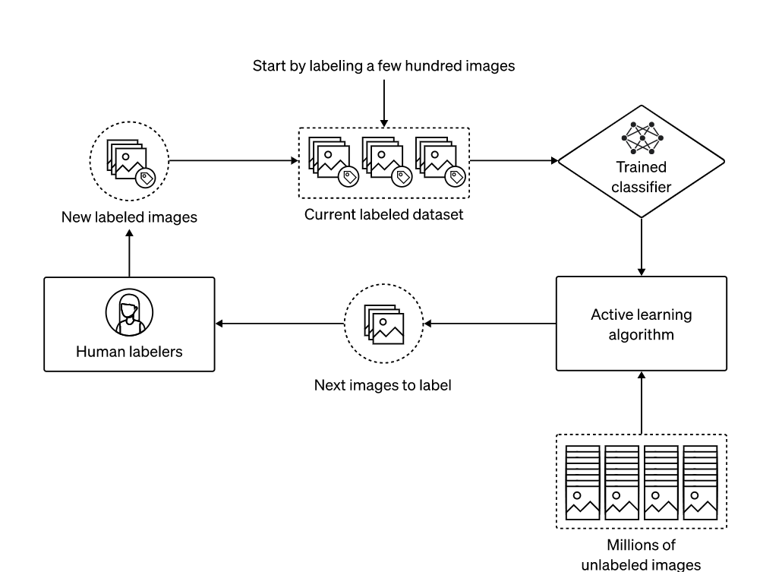

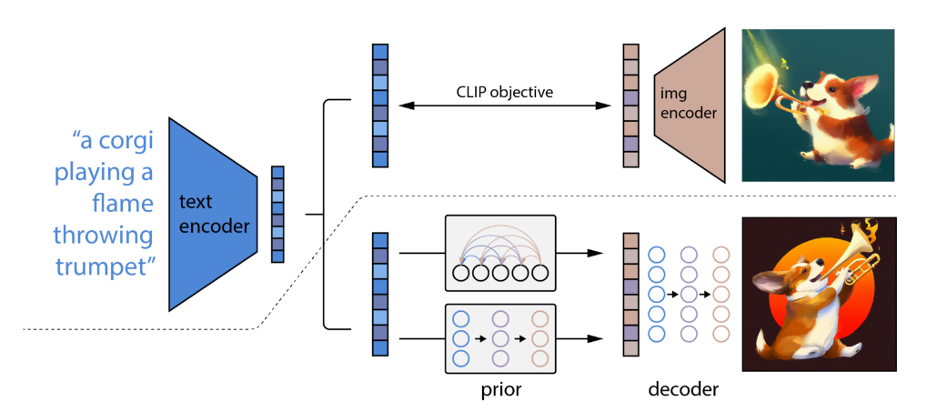

A textual representation of a data flow diagram for OpenAI ImageGenerator. it is an image generation model, and a typical data flow diagram might not capture the intricacies of its internal processes. However, we can outline a simplified data flow diagram for this module:

**1. User Input**: The user provides a textual description or prompt to generate an image.

**2. Input Processing:** The system processes the user input, tokenizes it, and prepares it for further processing.

**3. Text Encoding:** The text is encoded into a numerical representation that the model can understand.

**4. OpenAI Model:** The encoded text is fed into the DALL·E model, which generates an image based on the provided prompt.

**5. Image Generation:** This model processes the encoded text and generates a corresponding image.

**6. Image Rendering:** The generated image is rendered and prepared for display or further processing.

**7. Output Delivery:** The system delivers the generated image to the user or the intended recipient.

It's important to note that the actual data flow and internal processes of OpenAI Module are more complex and involve sophisticated deep learning techniques. The above representation simplifies the data flow for illustrative purposes, highlighting the core steps involved in generating an image from a textual prompt.

# CHAPTER 5

# 5.1 SOFTWARE REQUIREMENTS

|  |  |  |
| --- | --- | --- |
| **REQUIREMENT** | **SOFTWARE ELEMENTS** | **SPECIFICATION** |
| **Software** | **OS** | **WINDOWS, LINUX** |
| **React JS,**  **HTML**  **CSS, JavaScript** | **Visual Studio code ,** |

**5.2 HARDWARE REQUIREMENT**

|  |  |  |
| --- | --- | --- |
| **REQUIREMENT** | **HARDWARE ELEMENTS** | **SPECIFICATION** |
| **Hardware** | **Processor** | **i3** |
| **RAM** | **2GB** |
| **Hard Disk** | **250GB** |

# CHAPTER 6

# SYSTEM IMPLEMENTATION

# 6.1

1. **HTML** : (Hypertext Markup Language) is the standard markup language used to create and structure webpages. It uses a set of tags to define the elements and content within a webpage. These tags indicate headings, paragraphs, links, images, tables, forms, and more. HTML documents follow a hierarchical structure known as the Document Object Model (DOM), allowing for easy manipulation and interaction with webpage elements using scripting languages like JavaScript. HTML separates content from presentation, providing semantic meaning to different parts of a webpage. It supports multimedia elements and allows integration with stylesheets (CSS) and scripts (JavaScript). HTML is essential for web development, enabling the creation of accessible and interactive webpages.
2. **CSS**:(Cascading Style Sheets) is a language used to define the visual appearance and formatting of HTML documents. It works alongside HTML to separate content from presentation, allowing developers to control the layout, colors, fonts, and other visual aspects of a webpage. CSS achieves this by selecting HTML elements and applying styles to them using selectors and declarations. Selectors target specific elements or groups of elements, while declarations specify the desired styles, such as font size, background color, margins, and more. CSS provides flexibility and consistency across multiple webpages by enabling the use of external style sheets that can be shared among various HTML documents. It enhances the user experience, improves accessibility, and simplifies the maintenance of web designs.
3. **JavaScript:** JavaScript is a high-level programming language primarily used for adding interactivity and dynamic behavior to webpages. It enables developers to create responsive and interactive elements that can respond to user actions or events. JavaScript can manipulate and modify HTML and CSS elements on the fly, allowing for real-time updates and user-friendly experiences. It offers a wide range of functionalities, including form validation, animations,

dynamic content loading, data manipulation, and more. JavaScript can be executed on both the client-side (in the web browser) and the server-side (with Node.js), making it versatile for various web development scenarios. It is a key component in modern web applications,

powering dynamic web pages and enhancing user engagement.

1. **OpenAI:** The OpenAI API key is a unique identifier that grants access to the OpenAI GPT-3.5 language model and its capabilities. It acts as a secure authentication token that allows developers to make API requests and utilize the powerful natural language processing capabilities of GPT-3.5. The API key serves as a means to authenticate and track usage, ensuring that only authorized users can access and interact with the OpenAI model. With the API key, developers can send requests to the OpenAI API endpoint, passing in prompts or questions and receiving generated text or responses in return. It is an essential component for integrating the OpenAI language model into applications, chatbots, and other software systems, enabling developers to leverage the advanced language processing capabilities of GPT-3.5 in their own projects.
2. **React:** React is a popular JavaScript framework for building user interfaces (UI) in web applications. It allows developers to create reusable UI components that update efficiently and render dynamically based on changes in data. React follows a component-based architecture, where complex UIs are broken down into smaller, self-contained components, each managing its own state and behavior. It uses a virtual DOM (Document Object Model) to efficiently update only the necessary parts of the UI, resulting in improved performance. React promotes a declarative programming style, where developers describe the desired UI state and React takes care of updating the UI accordingly. It provides a rich ecosystem of libraries and tools, making it a versatile choice for building interactive and scalable web applications.

**6.2 SOFTWARE TESTING**

Software testing for the Image Generator project, developed by OpenAI, would involve a comprehensive and rigorous process to ensure the quality and reliability of the image generation model. Here is a brief explanation of software testing aspects that could be considered for this project:

**1. Unit Testing:** Test individual components and functions of the codebase to verify their correctness and ensure they behave as expected. This could include testing specific modules responsible for data processing, text encoding, image generation, and other core functionalities.

**2. Integration Testing:** Validate the interaction and integration between different modules or components of this system. This ensures that the system functions seamlessly as a whole, with proper data flow and communication between various parts of the model.

**3. Functional Testing:** Verify that the model performs its intended function correctly, which is to generate images based on textual prompts. Test different input scenarios and validate the generated images against expected outputs, ensuring they align with the provided prompts.

**4. Performance Testing:** Assess the performance of the model in terms of its speed, scalability, and resource utilization. This testing helps identify any bottlenecks, performance issues, or optimization opportunities that could enhance the efficiency of image generation.

**5. Robustness Testing:** Evaluate the DALL·E model's ability to handle unexpected or invalid inputs gracefully. Test edge cases, exceptional inputs, and boundary conditions to ensure the model doesn't crash or produce incorrect results, providing robustness and resilience.

**6. Security Testing:** Assess the DALL·E system for potential security vulnerabilities, ensuring that it doesn't expose sensitive data or have vulnerabilities that could be exploited by malicious actors. This includes testing for data privacy, access controls, and protection against potential attacks.

**7. Compatibility Testing:** Verify the compatibility of the system across different platforms, operating systems, and browsers, if applicable. This ensures that the model can be deployed and used effectively across a variety of environments.

**8. User Acceptance** Testing: Involve end users or stakeholders to test the system from a user's perspective. Collect feedback, assess user satisfaction, and ensure that the generated images meet their expectations and requirements.

**9. Regression Testing:** Conduct regular regression testing to ensure that new updates or modifications to the system do not introduce new bugs or regressions. This involves retesting previously validated functionalities to ensure they still work as expected.

**10. Documentation Testing:** Validate the accuracy and completeness of the documentation accompanying the project. This includes the user guide, API documentation, code comments, and any other relevant documentation artifacts.

**6.3 SOURCE CODE**

**HTML CODE:**

<!DOCTYPE html>

<html lang="en">

<head>

<meta charset="UTF-8" />

<meta http-equiv="X-UA-Compatible" content="IE=edge" />

<meta name="viewport" content="width=device-width, initial-scale=1.0" />

<link rel="stylesheet" href="css/style.css" />

<link rel="stylesheet" href="css/spinner.css" />

<script src="js/main.js" defer></script>

<title>Image Genrator Using OPENAI</title>

</head>

<body>

<header>

<div class="navbar">

<div class="logo">

<h2>AI Image Genrator</h2>

</div>

<div class="nav-links">

<ul>

<li>

<a href="https://beta.openai.com/docs" target="_blank"

>OpenAI API Docs</a

>

</li>

</ul>

</div>

</div>

</header>

<main>

<section class="showcase">

<form id="image-form">

<h1>Describe An Image</h1>

<div class="form-control">

<input type="text" id="prompt" placeholder="Enter Text" />

</div>

<!-- size -->

<div class="form-control">

<select name="size" id="size">

<option value="small">Small</option>

<option value="medium" selected>Medium</option>

<option value="large">Large</option>

</select>

</div>

<button type="submit" class="btn">Generate</button>

</form>

</section>

<section class="image">

<div class="image-container">

<h2 class="msg"></h2>

<img src="" alt="" id="image" />

</div>

</section>

</main>

<div class="spinner"></div>

</body>

</html>

**JavaScript CODE:**

function onSubmit(e) {

e.preventDefault();

document.querySelector('.msg').textContent = '';

document.querySelector('#image').src = '';

const prompt = document.querySelector('#prompt').value;

const size = document.querySelector('#size').value;

if (prompt === '') {

alert('Please add some text');

return;

}

generateImageRequest(prompt, size);

}

async function generateImageRequest(prompt, size) {

try {

showSpinner();

const response = await fetch('/openai/generateimage', {

method: 'POST',

headers: {

'Content-Type': 'application/json',

},

body: JSON.stringify({

prompt,

size,

}),

});

if (!response.ok) {

removeSpinner();

throw new Error('That image could not be generated');

}

const data = await response.json();

// console.log(data);

const imageUrl = data.data;

document.querySelector('#image').src = imageUrl;

removeSpinner();

} catch (error) {

document.querySelector('.msg').textContent = error;

}

}

function showSpinner() {

document.querySelector('.spinner').classList.add('show');

}

function removeSpinner() {

document.querySelector('.spinner').classList.remove('show');

}

document.querySelector('#image-form').addEventListener('submit', onSubmit);

**OpenAIController:**

const { Configuration, OpenAIApi } = require('openai');

const configuration = new Configuration({

apiKey: process.env.OPENAI_API_KEY,

});

const openai = new OpenAIApi(configuration);

const generateImage = async (req, res) => {

const { prompt,size } = req.body;

const imageSize = size === 'small' ? '256x256' : size === 'medium' ? '512x512' : '1024x1024';

try{

const response = await openai.createImage({

prompt,

n: 1,

size: imageSize,

});

const imageUrl = response.data.data[0].url

res.status(200).json({

success: true,

data: imageUrl

});

} catch (error) {

if (error.response) {

console.log(error.response.status);

console.log(error.response.data);

} else {

console.log(error.message);

}

res.status(400).json({

success: false,

error: 'the image could not be generated'

});

}

};

module.exports = { generateImage };

**CSS CODE:**

@import url('https://fonts.googleapis.com/css2?family=Poppins:wght@300;400;700&display=swap');

*,

*:before,

*:after {

box-sizing: border-box;

margin: 0;

padding: 0;

}

:root {

--primary-color: #eb2188;

}

body {

font-family: 'Poppins', sans-serif;

font-size: 16px;

line-height: 1.5;

color: #333;

background: #080a52;

}

/* Navbar */

.navbar {

background: #000000;

color: #fff;

padding: 1rem;

display: flex;

justify-content: space-between;

align-items: center;

}

.navbar ul {

list-style: none;

display: flex;

}

.navbar ul li {

margin-left: 1rem;

}

.navbar a {

color: #fff;

text-decoration: none;

font-size: 1.2rem;

}

.navbar a:hover {

color: var(--primary-color);

}

/* Showcase */

.showcase {

height: 450px;

width: 100%;

background: var(--primary-color);

}

.showcase h1 {

font-size: 2.5rem;

color: #333;

text-align: center;

padding: 1rem 0;

}

.showcase form {

display: flex;

align-items: center;

justify-content: center;

flex-direction: column;

height: 100%;

width: 100%;

}

.showcase form input,

form select {

font-size: 20px;

width: 500px;

max-width: 500px;

padding: 1rem;

border: 1px solid #ccc;

border-radius: 5px;

margin-bottom: 1rem;

}

form button {

font-size: 20px;

padding: 1rem 2rem;

border: none;

border-radius: 5px;

background: #333;

color: #fff;

cursor: pointer;

margin-top: 20px;

}

form button:hover {

transform: scale(1.1);

}

/* Image */

.image {

width: 100%;

margin-top: 2rem;

}

img {

display: block;

margin: auto;

}

.msg {

font-size: 1.6rem;

text-align: center;

margin-top: 1rem;

}

**CHAPTER 7**

**TESTING**

## Image Generated by OpenAI

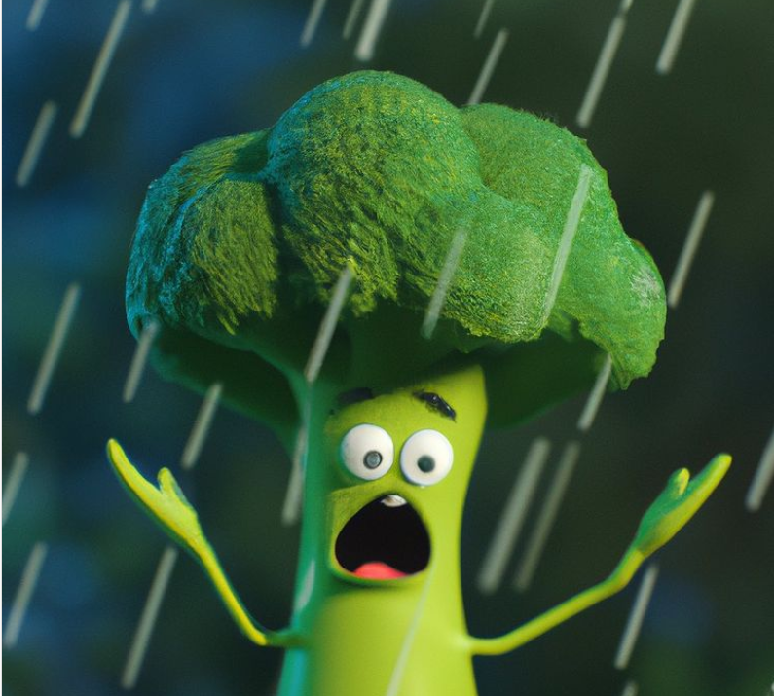

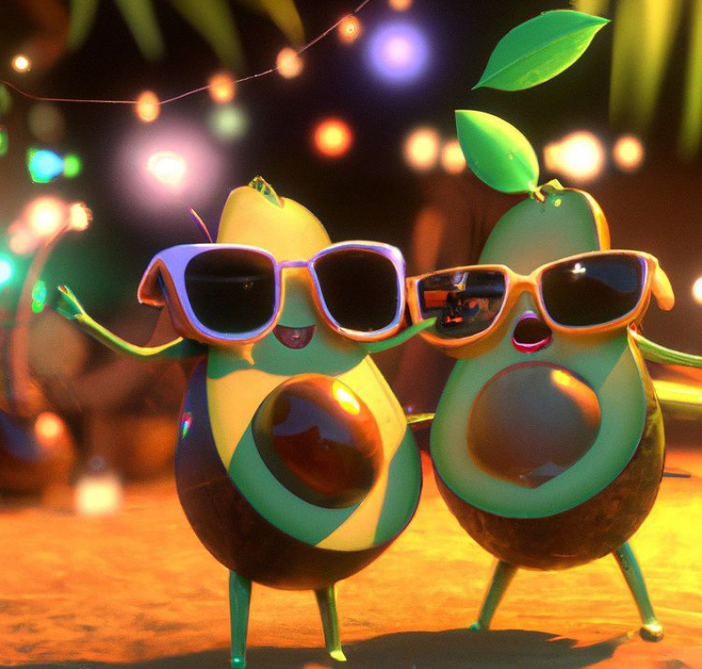

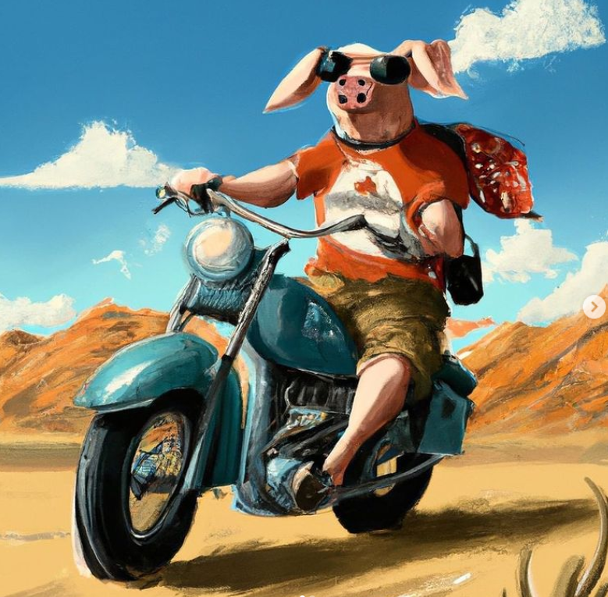

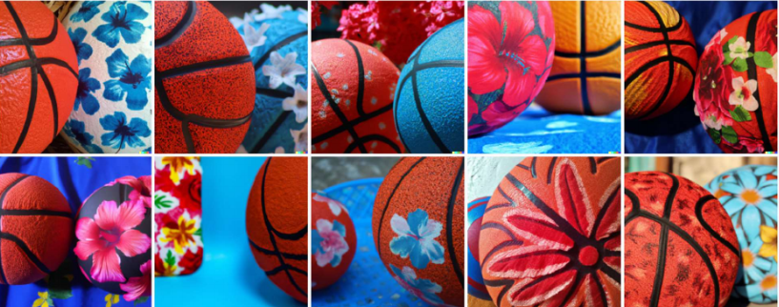

**CHAPTER 8**

**CONCLUSION**

In conclusion, Image Generator project has revolutionized the fields of computer vision and natural language processing, showcasing the incredible potential of AI in generating visual content from textual descriptions. Through its groundbreaking capabilities, OpenAI has transformed the creative process, empowering artists, designers, and content creators to bring their ideas to life with ease and efficiency.

Moreover, it has extended its impact beyond the realm of art and design. Its applications in e-commerce have the potential to reshape online shopping experiences by providing realistic product visualizations, bridging the gap between physical and digital retail environments. In the medical field, it has ability to generate medical images and aid in diagnostics has the potential to enhance healthcare practices and improve patient outcomes.

While the benefits of this module are undeniable, ethical considerations must be at the forefront of its development and deployment. Guarding against copyright infringement and addressing the risks associated with deepfakes and deceptive content is crucial. Regulations and responsible use guidelines must be established to ensure the technology is employed in a manner that aligns with societal values and safeguards against misuse.

Challenges lie ahead for module, such as refining the model's prompt understanding and addressing biases in generated outputs. Ongoing research and collaboration will be necessary to overcome these obstacles and further enhance the model's capabilities. Additionally, efforts to diversify the training data and improve the realism and contextual understanding of the generated images will be key to advancing the technology.

Looking to the future, it holds tremendous promise. Continued research and development can lead to even more advanced iterations of the model, enabling it to generate images with unparalleled detail, realism, and context sensitivity. The collaboration between researchers, artists, and industry professionals will be instrumental in pushing the boundaries of OpenAI applications and exploring new frontiers.

Open-source initiatives and community involvement will play a vital role in the evolution of OpenAI. Embracing a collective approach to its development will ensure a wide range of perspectives are considered, fostering innovation and inclusivity in the technology's use. By combining human creativity

with AI capabilities, OpenAI has the potential to unlock groundbreaking solutions and drive transformative change across various domains.

In summary, the ImageGenerator project has introduced a remarkable breakthrough in AI-driven image generation. Its impact spans creative industries, e-commerce, healthcare, and beyond. With responsible development and deployment, it can enhance human creativity, improve user experiences, and revolutionize how we interact with visual content. As we venture into a future shaped by AI, the journey of it represents an inspiring fusion of human imagination and machine intelligence, paving the way for a new era of visual expression and innovation.

**REFERENCES**

[**https://labs.openai.com/**](%20https:/labs.openai.com/)